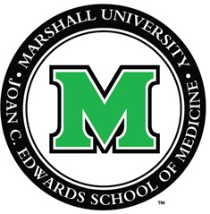
JOAN C. EDWARDS SCHOOL OF MEDICINE
ANNUAL AWARDS CEREMONY
Wednesday, December 10, 2025 • 5:30 PM
Marshall University Medical Center Harless Auditorium

WELCOME

Darshana Shah, PhD, Professor of Pathology
Senior Associate Dean, Office for Faculty Advancement

PRESENTATION OF MASTER CLINICIAN AWARD
Joseph Werthammer, MD, FAAP, Professor of Pediatrics
Chair, Department of Pediatrics

Master Clinician Award
Lynne Goebel, MD, Professor of Internal Medicine

PRESENTATION OF FACULTY AND TRAINEE AWARDS
Dana Lycans, MD, FAAOS, Associate Professor, Orthopedic Surgery
Vice Chair, Faculty Council

EDUCATION AWARDS

RESEARCH AWARDS

Distinguished Teacher of the Year
Matthew Bullock, DO, Professor of Orthopedic Surgery
Excellence in Teaching Award
Ibrahim Shanti, MD, Internal Medicine
Aspiring Teacher of the Year
Alec Phelps, MS-3

Distinguished Researcher of the Year
Todd Davies, PhD, Associate Professor of Family Medicine
Excellence in Research Award
Zakaria Alagha, MBBCH, Pulmonary and Critical Care
Aspiring Researcher of the Year
Rebecca Hicks, MS-3

CLINICAL CARE AWARDS
Distinguished Clinician of the Year
Elizabeth Saunders, MD, Associate Professor of Internal Medicine
Excellence in Clinical Care Award
Abdul Muhsen Abdeen, MD, Internal Medicine
Aspiring Clinician of the Year
Emily King

CLOSING REMARKS

David Gozal, MD, MBA, PhD (Hon) Dean, Joan C. Edwards School of Medicine
Vice President for Health Affairs

