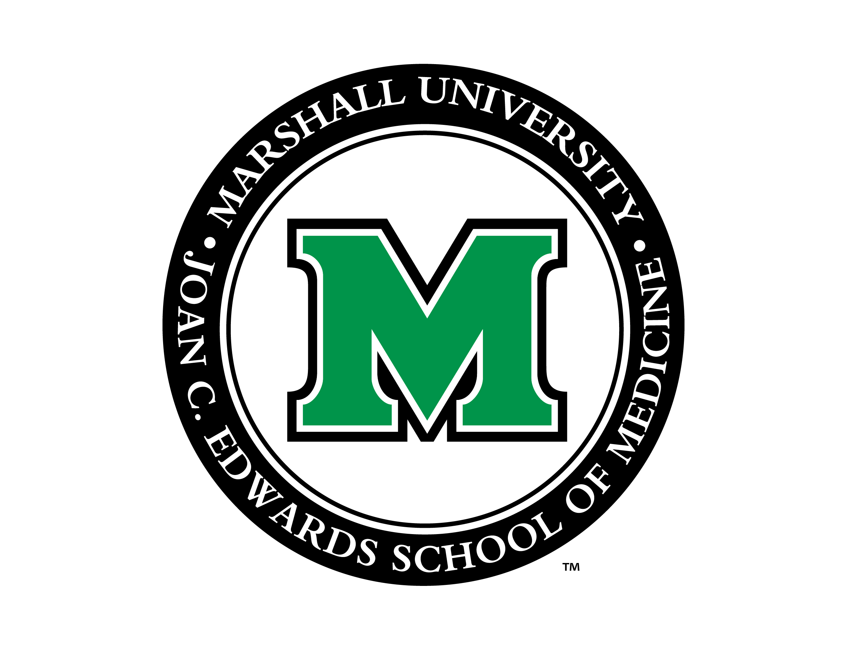Letter of Agreement 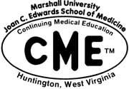
(must be completed and signed for all outside funding)

for ACCME Accredited CME Providers
regarding terms, conditions and purposes of an Educational Grant
Form must be typed or printed legibly.

Parties Involved:

CME Provider: Marshall University JCE School of Medicine CME

Educational Partner / Joint Provider (Non-Commercial):

Supporting Commercial Company / Institution:

Title of CE Activity

Location ____________________________ Date(s)

(A commercial interest is any entity producing, marketing , re-selling, or distributing health care goods or services consumed by, or used on patients.)
Educational Partner / Joint Provider Information: Supporting Commercial Company Information:

Contact Person Contact Person

Address Address

City City

State________Zip State________Zip

E-mail E-mail

Telephone ( )_______________Fax ( ) Telephone ( )_______________Fax ( )

The supporting company wishes to provide support for the named cme activity by means of (indicate which option):

- Educational grant to offset conference expenses in the amount of $

- In-Kind (facility, equipment, etc) Support – Please Describe:

- Exhibit Fee in the amount of $

Conditions

- Statement of Purpose: program is for scientific and educational purposes only and will not promote the company’s products, directly or indirectly.

- Control of content & Selection of Presenters & Moderators: Marshall University JCE Scool of Medicine CME is responsible for control of content and selection of presenters and moderators. The Supporting Company agrees not to direct the content of the program.

- Disclosure of Financial Relationships: Marshall University JCE School of Medicine CME will ensure full disclosure to the audience at the time of the program either verbally or in writing, of (a) Supporting Company funding and (b) any relevant relationship between Marshall University JCE School of Medicine CME and the Supporting Company (e.g., grant recipient) or between individual speakers or moderators and the Supporting Company. All identified conflicts of interest will be resolved prior to the activity.

- Involvement in Content: There will be no “scripting”, emphasis, or direction of content by the Supporting Company or its agents.

- Ancillary Promotional Activities: no promotional activities will be permitted in the same room or obligate path as the educational activity. No product advertisements will be permitted in the program room.

- Objectivity & Balance: Marshall University JCE School of Medicine CME will make every effort to ensure that data regarding the supporting company’s products (or competing products) are objectively selected and presented, with favorable and unfavorable information and balanced discussion of prevailing information on the product(s) and/or alternative treatments.

- Limitations on Data: Marshall University JCE School of Medicine CME will ensure, to the extent possible, meaningful disclosure of limitations on data, e.g., ongoing research, interim analyses, preliminary data, or unsupported opinion.

- Discussion of Unapproved Uses: Marshall University JCE School of Medicine CME will require that presenters disclose when a product is not approved in the United States for the use under discussion.

- Opportunities for Debate: Marshall University JCE School of Medicine CME will ensure opportunities for questioning or scientific debate.

- Independence of Marshall University JCE School of Medicine CME in the use of Contributed Funds:

  - Funds should be in the form of an educational grant made payable to:

- Educational Partner / Joint Provider:

- Marshall University JCE School of Medicine Department of

- MUJCESOM Continuing Medical Education c/o Marshall Health. Tax ID: 55-0564945
(Marshall Health is the account holder for MUJCESOM CME)

  - All other support associated with this educational activity (e.g., distributing brochures, preparing slides, etc.) must be given with the full knowledge and approval of Marshall University JCE School of Medicine CME.

  - No other funds from the supporting company will be paid to the program director, faculty, or others involved with the education activity (additional honoraria, extra social events, etc.).

  - The Educational Partner / Joint Provider shall provide a full accounting of income and expenses to MUJCESOM CME. This accounting will include proof (copies of checks, etc.) of all payments made to faculty, including, but not limited to, honorarium and travel reimbursements. Expenses subtotals will be provided for the following categories: 1) Publicity, 2) Hospitality/food, 3) speaker honoraria, 4) speaker travel, 5) CE expenses, and 6) Miscellaneous. Individual miscellaneous expenses that exceed $1000 also should be broken out into a subcategory.

Educational Partner / Joint Provider Representative initials: __________

The Supporting Company, the Provider, and the Educational Partner / Joint Provider agree to abide by all requirements of the ACCME Standards for Commercial Support of Continuing Medical Education.

Marshall University JCE School of Medicine CME agrees to: 1) abide by the ACCME Standards for Commercial Support of Continuing Medical Education, 2) acknowledge educational support from the supporting company in program brochures (confirmed at press time), syllabi, and other program materials (no company logos are allowed), and 3) upon request, furnish the supporting company a report concerning the expenditure of the funds provided.

Must Be Signed and Date PRIOR to the date of the activity:

Agreed

Supporting Company/Institution Representative (name)

Signature Date

Educational Partner / Joint Provider Representative (name)

Signature Date

Course Director (name)

Signature Date

CME Assistant Dean or Designee (name)

Signature Date

